CI/CD pipeling is a series of automated processes.

Stages fo CI/CD:

* Continuous integration
* Continuous deliver
* Continuous deployment

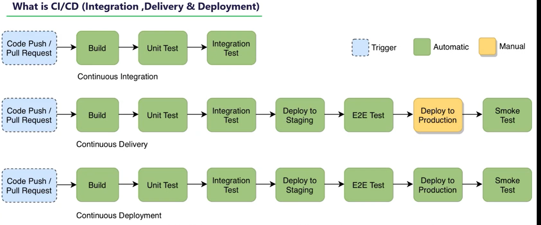

**Continuous** **Integration**  **Continuous Delivery Continuous Deployment**

Automatically deploy to production

Automatically release to repository

Merge

Test

Build

Continuous Integrations: